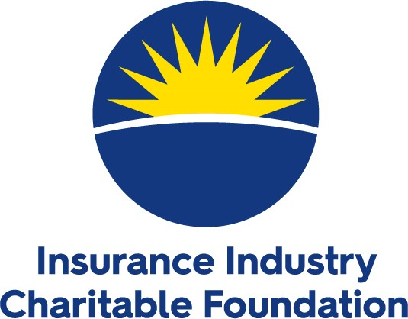
Northeast Division
Local Grant Guidelines

The IICF Northeast Division will award up to ten grants of $2,500 in the New York Tri-State in 2021. State and regional companies, local insurance organizations, agents, and brokers are encouraged to sponsor their favorite charities for these grants.

Guidelines for applying:
- An insurance industry sponsor is required for each applicant
- All charities must be 501(c)(3) public charities, and their public charity status must be confirmed by their IRS determination letter
- Grants cannot be given to religious or political organizations or scholarships specific to the insurance industry
- All charities must serve in New York, New Jersey, or Connecticut
- All grant prospects must complete the 2021 application and submit all documentation by May 28, 2021
- Grant funding will be awarded in Q3 2021
- Priority will be given to new applications with budget revenues below $2M
- Grant recipients may receive grants for a maximum of three consecutive years. After receiving three consecutive grants, the grantee will be ineligible to apply for a grant for one year.
The IICF Northeast Division Local Grants Committee takes their responsibilities seriously and has a rigorous review process for their grant selection. Submission of the application does not, in any way, guarantee that an applicant will receive funding.

