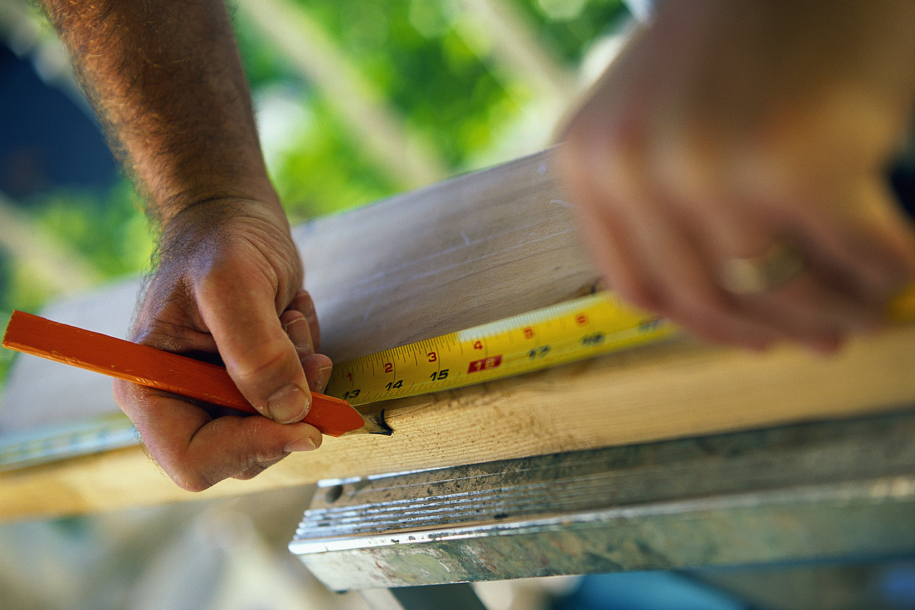
Take Care When Hiring
A Home Improvement Contractor
To make sure that you’re working with a reputable contractor:
- Hire only contractors who have the appropriate licenses. Home improvement contractors operating in New York City and Putnam, Rockland, Westchester, Nassau and Suffolk Counties must be licensed by the county or by the town where the work is being done.
- Hire only contractors who carry business liability and workers’ compensation insurance. Ask for a certificate of insurance, which lists the contractor’s insurance company, the amount of insurance the contractor is carrying, and when the policy is due to expire.
- Although contractors will be in high demand for some time after the storm, try to obtain estimates from at least two contractors. It always pays to comparison shop.
- Hire LOCAL contractors. They make their living in the area and have reputations to protect.

When choosing a contractor to repair
the storm damage to your home,
avoid contractors who:
- Claim that they have been “approved” by the Federal Emergency Management Agency (“FEMA”). FEMA does not approve or disapprove contractors.
- Insist that you pay for the work in cash and in advance. Municipalities and counties prohibit licensed contractors from doing this.
- Do not itemize the price of construction materials in the work estimate. While price increases for construction supplies after a major storm are normal, extreme price hikes are illegal.
- A licensed contractor must separately list supply costs so you can tell whether the charge is fair.

To report possible price-gouging, contact the New York State Attorney General:
Phone: 800-771-7755
Online: www.ag.ny.gov/hurricane-sandy-price-gouging-complaint-form

To locate licensed contractors in your area, visit
- www.libi.org
- www.nari.org
- New York City Department of Consumer Affairs
www.nyc.gov/html/dca/html/licenses/license_check.shtml
- Nassau County Office of Consumer Affairs
www.nassaucountyny.gov/agencies/OCA/index.html
- Putnam County Consumer Affairs, Home Improvement Board
www.putnamcountyny.com/index.php/consumer-affairs/home-improvement-board/
- Rockland County Consumer Protection/Weights & Measures
http://rocklandgov.com/departments/consumer-protection-weights-and-measures/licensed-businesses/
- Suffolk County Consumer Affairs, Licensing Bureau
www.suffolkcountyny.gov/Departments/ConsumerAffairs/Bureaus/LicensingBureau.aspx
- Westchester County Consumer Department
http://consumer.westchestergov.com/find-a-licensed-contractor

For information on available government assistance, visit www.disasterassistance.gov

